Denford LTD

COMPUTERISED MACHINES AND SYSTEMS

Denford Limited
Birds Royd, Brighouse, West Yorkshire
HD6 1NB, England.
Telephone: 01484 712264
Fax: 01484 722160
Email:info@denford.co.uk

16 BIT INDUSTRIAL I/O BOARD

MANUAL

16.5.2000

IO MANUAL.DOC

Component Layout

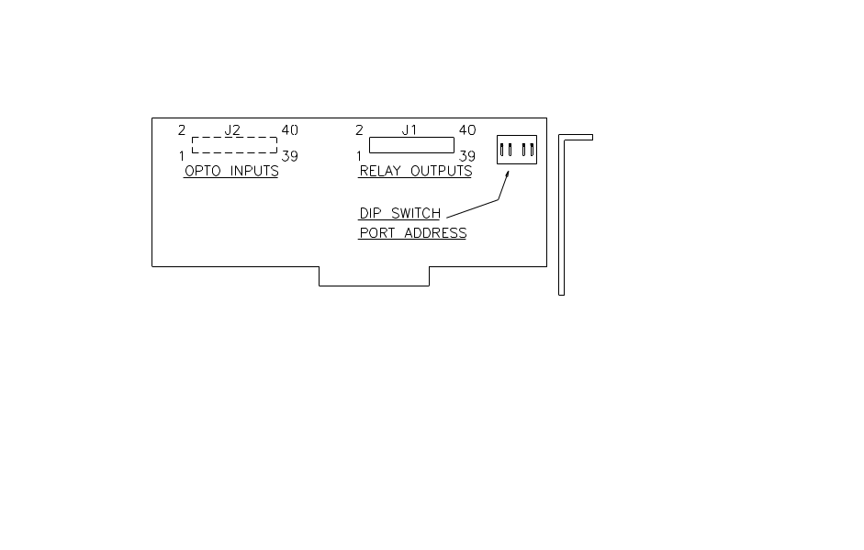

DIP Switch settings

SW1 SW2 SW3 I/O Card Board Address
ON ON ON $ 170 - $17F
ON ON OFF $ 180 - $18F
ON OFF ON $ 190 - $19F
ON OFF OFF $ 1A0 - $1AF
OFF ON ON $ 330 - $33F
OFF ON OFF $ 360 - $36F
OFF OFF ON $ 390 - $39F
OFF OFF OFF $ 3C0 - $3CF

(SW4 Not Used)

Connector J1 (OUTPUT Relays)

PIN | DISCRIPTION | PORT ADDRESS | BIT ADDRESS
1,2 | RELAY 1 | PORT* +0 | BIT 0
3,4 | RELAY 2 | PORT +0 | BIT 1
5,6 | RELAY 3 | PORT +0 | BIT 2
7,8 | RELAY 4 | PORT +0 | BIT 3
9,10 | RELAY 5 | PORT +0 | BIT 4
11,12 | RELAY 6 | PORT +0 | BIT 5
13,14 | RELAY 7 | PORT +0 | BIT 6
15,16 | RELAY 8 | PORT +0 | BIT 7
17,18 | RELAY 9 | PORT +1 | BIT 0
19,20 | RELAY 10 | PORT +1 | BIT 1
21,22 | RELAY 11 | PORT +1 | BIT 2
23,24 | RELAY 12 | PORT +1 | BIT 3
25,26 | RELAY 13 | PORT +1 | BIT 4
27,28 | RELAY 14 | PORT +1 | BIT 5
29,30 | RELAY 15 | PORT +1 | BIT 6
31,32 | RELAY 16 | PORT +1 | BIT 7
33,34 | GROUND
35,36 | DC +5V
37,38 | DC +12V
39,40 | GROUND

*Port $170

Connector J2 (INPUT Opto’s)

PIN | DISCRIPTION | PORT ADDRESS | BIT ADDRESS
1 | IN +1 | PORT +2 | BIT 0
2 | IN -1 | PORT +2 | BIT 0
3 | IN +2 | PORT +2 | BIT 1
4 | IN -2 | PORT +2 | BIT 1
5 | IN +3 | PORT +2 | BIT 2
6 | IN -3 | PORT +2 | BIT 2
7 | IN +4 | PORT +2 | BIT 3
8 | IN -4 | PORT +2 | BIT 3
9 | IN +5 | PORT +2 | BIT 4
10 | IN -5 | PORT +2 | BIT 4
11 | IN +6 | PORT +2 | BIT 5
12 | IN -6 | PORT +2 | BIT 5
13 | IN +7 | PORT +2 | BIT 6
14 | IN -7 | PORT +2 | BIT 6
15 | IN +8 | PORT +2 | BIT 7
16 | IN -8 | PORT +2 | BIT 7
17 | IN +9 | PORT +3 | BIT 0
18 | IN -9 | PORT +3 | BIT 0
19 | IN +10 | PORT +3 | BIT 1
20 | IN -10 | PORT +3 | BIT 1
21 | IN +11 | PORT +3 | BIT 2
22 | IN -11 | PORT +3 | BIT 2
23 | IN +12 | PORT +3 | BIT 3
24 | IN -12 | PORT +3 | BIT 3
25 | IN +13 | PORT +3 | BIT 4
26 | IN -13 | PORT +3 | BIT 4
27 | IN +14 | PORT +3 | BIT 5
28 | IN -14 | PORT +3 | BIT 5
29 | IN +15 | PORT +3 | BIT 6
30 | IN -15 | PORT +3 | BIT 6
31 | IN +16 | PORT +3 | BIT 7
32 | IN -16 | PORT +3 | BIT 7
33 | GROUND
34 | GROUND
35 | DC +5V
36 | DC +5V
37 | DC +12V
38 | DC +12V
39 | GROUND
40 | GROUND

